1. **Design Overview**

1.1. Data Flow Diagram Level 0:

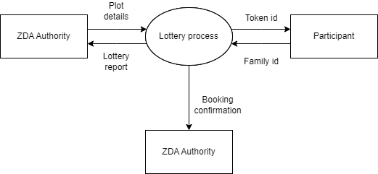

1.2. Data Flow Diagram Level 1:

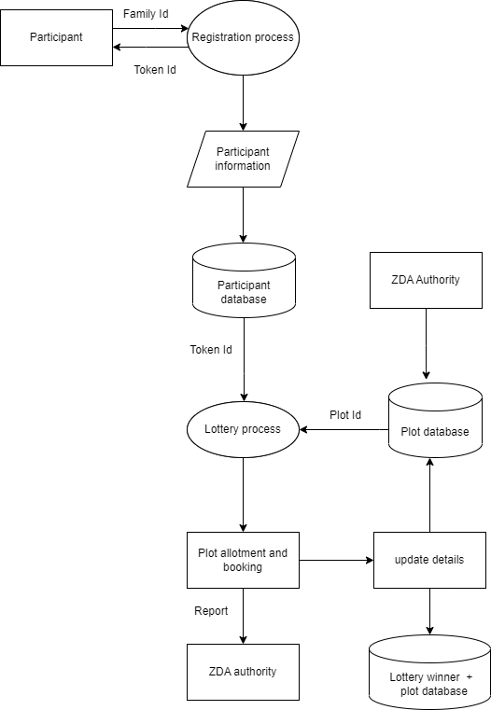

1.3. Flowchart for lottery Process:

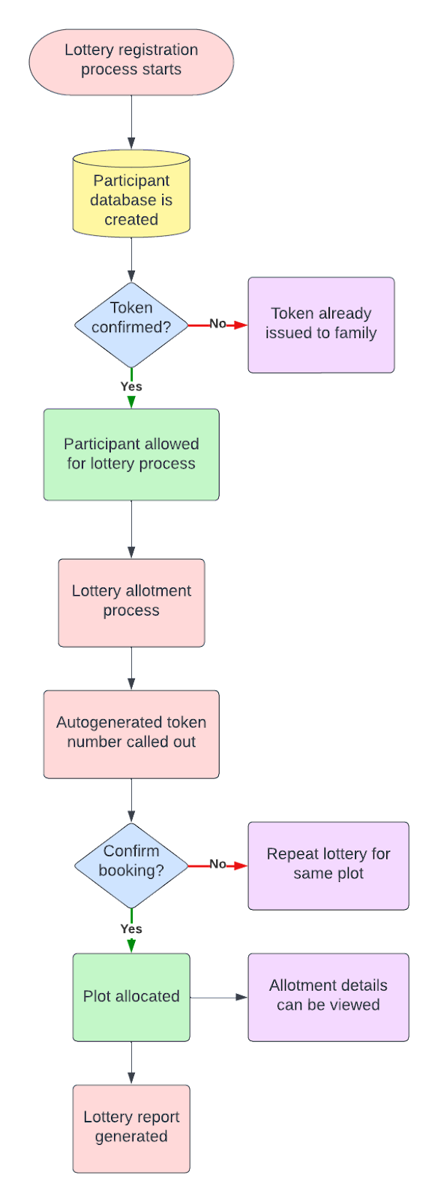

1.4. Flowchart for Main Menu:

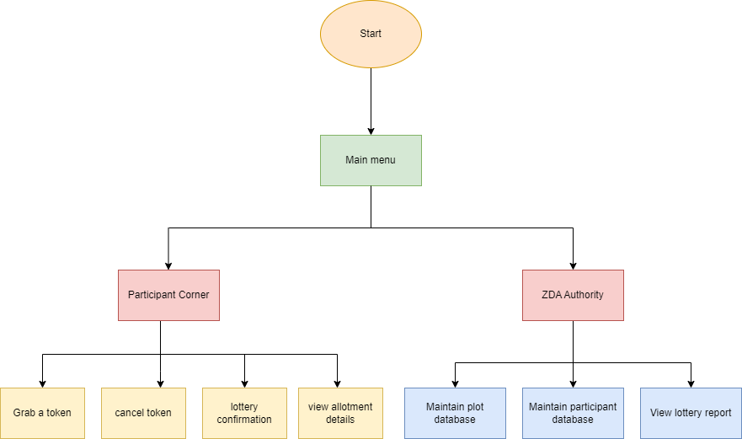

1.5. Flowchart for Maintain participant database:

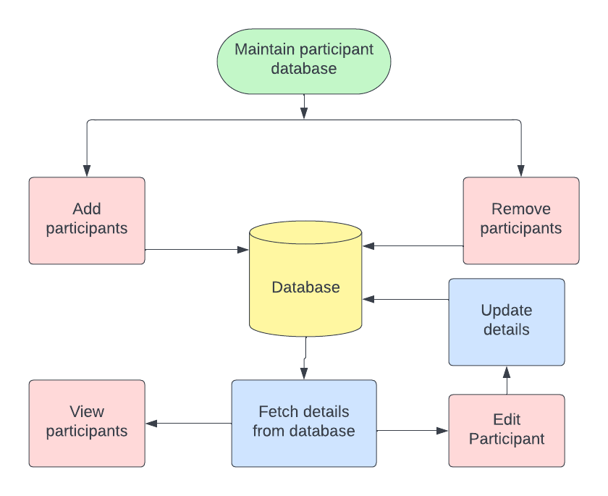

1.6. Flowchart for maintain plot database:

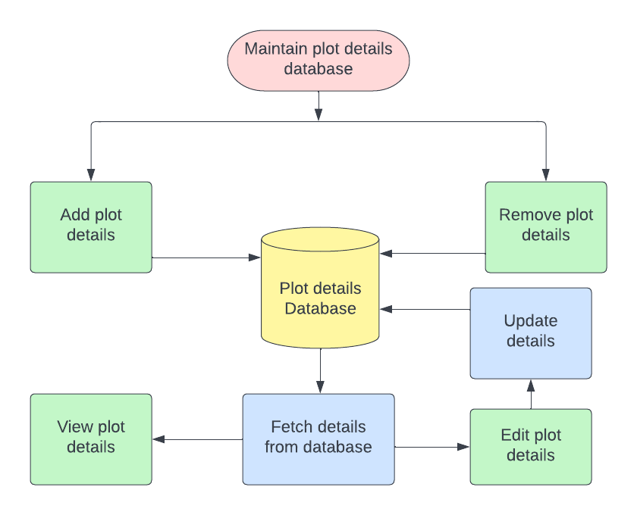

1. **System Architecture:**

2.1. Functions:

**2.1.1. PARTICIPANT CORNER:**

With only 300 tokens up for grabs on the website, only 300 out of 500 households can participate in the lottery process. Every family has a unique family Id and can grab only 1 token. Participants can register in the lottery by entering their family Id and  can participate in the process after getting confirmation.

2.1.1.1.  Grab a token:

Participant grabs a token in order to register for the lottery using his unique family Id.

2.1.1.2.  Cancel token:

If the present date is within 2 days before the actual lottery date, then the participants are not allowed to cancel their token or else their token is canceled and the participant database is updated.

2.1.1.3. Lottery Confirmation:

After the ZDA authority declares the winning lottery number for a plot, the winning family can confirm the booking by paying Rs.50000/- within 5 minutes and the database is updated.

2.1.1.4.  View allotment details:

This function displays the plot allotment details of the participant.

**2.1.2. ZDA AUTHORITY:**

ZDA Authority is responsible for maintaining the databases for the participants and plots by adding, editing, deleting and viewing the details in each database. They have access to the final lottery report and booking confirmation of the plots. ZDA Authorities have to access the admin features by entering the password.

2.1.2.1.  Add Plot details:

ZDA Authority can add the information about the plots that are to be won via lottery using admin features. We can get information like plot Id, plot size, price, etc.

2.1.2.2.  Edit plot details:

using this function, the features of the plots can be edited by using admin features.

2.1.2.3.  Delete plot details:

ZDA Authority can delete the information about a plot.

2.1.2.4.  View plot details:

ZDA Authority can view the details of all plots.

2.1.2.5.  Add participant details:

The information of the participants are entered into the database by the ZDA authority. Information such as family Id, name,plot no. and price to be paid are found here. The plot no. and price to be paid column are updated automatically after plot allotment.

2.1.2.6.  Edit participant details:

 ZDA Authority can update the participant information through this.

2.1.2.7.  Remove participant:

Details of participants can be deleted from the participant database.

2.1.2.8.  View participant details:

ZDA Authority can view information about all participants.

2.2. Structures:

Participant:

This structure is used to store information about the participant of the lottery. It contains structure members like Family_id, name, participated in lottery or not, plot_no., token_no., size of plot and remaining_amount.

Plot:

This structure contains structure members like plot_no., size of plot, allot, and price of plot in order to describe the features of a plot.